Two-Tier System
# Source: AI Source: Provided by: [Data Path: Persons Table -> ID Column: 1, Name_En Column: Motasem Essam] -> From: [ChatGPT] on [1/16/2026]
A Two-tier architecture is a type of client–server system where the application is divided into two layers (tiers):
- Client Tier
- Server Tier
The client communicates directly with the server.

Definition
# Source: AI Source: Provided by: [Data Path: Persons Table -> ID Column: 1, Name_En Column: Motasem Essam] -> From: [ChatGPT] on [1/16/2026]
In a Two-tier system:
- The client handles the user interface and often part of the business logic
- The server handles data storage and management (usually a database)
- There is no middle layer

Architecture Diagram
# Source: AI Source: Provided by: [Data Path: Persons Table -> ID Column: 1, Name_En Column: Motasem Essam] -> From: [ChatGPT] on [1/16/2026]
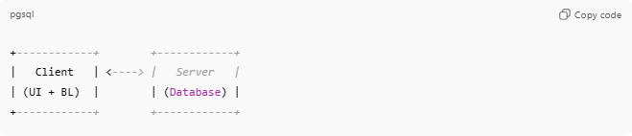
+------------+ +------------+
| Client | <----> | Server |
| (UI + BL) | | (Database) |
+------------+ +------------+
- UI = User Interface
- BL = Business Logic

How It Works
# Source: AI Source: Provided by: [Data Path: Persons Table -> ID Column: 1, Name_En Column: Motasem Essam] -> From: [ChatGPT] on [1/16/2026]
- User interacts with the client application
- Client sends a request directly to the server
- Server processes the request and returns data
- Client displays the result

Real-World Examples
# Source: AI Source: Provided by: [Data Path: Persons Table -> ID Column: 1, Name_En Column: Motasem Essam] -> From: [ChatGPT] on [1/16/2026]
- Desktop application connected directly to a database
- MySQL / Oracle DB accessed by a Java or .NET client
- Small-scale business applications
- Client–database systems in local networks

Characteristics
# Source: AI Source: Provided by: [Data Path: Persons Table -> ID Column: 1, Name_En Column: Motasem Essam] -> From: [ChatGPT] on [1/16/2026]
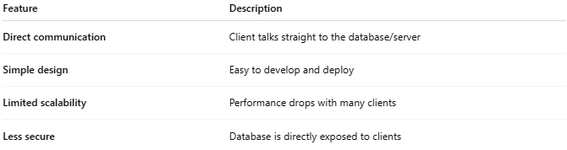
Feature | Description
Direct communication | Client talks straight to the database/server
Simple design | Easy to develop and deploy
Limited scalability | Performance drops with many clients
Less secure | Database is directly exposed to clients

Advantages
# Source: AI Source: Provided by: [Data Path: Persons Table -> ID Column: 1, Name_En Column: Motasem Essam] -> From: [ChatGPT] on [1/16/2026]
- Simple architecture
- Fast communication (no middle layer)
- Easy to implement for small systems

Disadvantages
# Source: AI Source: Provided by: [Data Path: Persons Table -> ID Column: 1, Name_En Column: Motasem Essam] -> From: [ChatGPT] on [1/16/2026]
- Poor scalability
- Difficult to maintain for large systems
- Security risks (clients access database directly)
- Not suitable for internet-scale applications

Comparison: Two-Tier vs Three-Tier
# Source: AI Source: Provided by: [Data Path: Persons Table -> ID Column: 1, Name_En Column: Motasem Essam] -> From: [ChatGPT] on [1/16/2026]
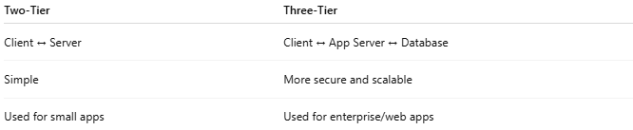
Two-Tier | Three-Tier
Client ↔ Server | Client ↔ App Server ↔ Database
Simple | More secure and scalable
Used for small apps | Used for enterprise/web apps

Easy Analogy
# Source: AI Source: Provided by: [Data Path: Persons Table -> ID Column: 1, Name_En Column: Motasem Essam] -> From: [ChatGPT] on [1/16/2026]
- Two-Tier: Customer talks directly to the chef
- Three-Tier: Customer → waiter → chef

